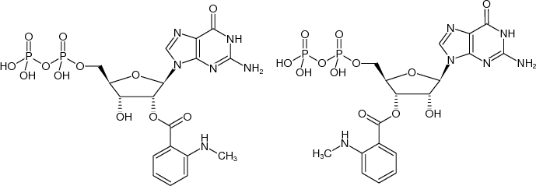
Figure S1. The chemical structure of mant-GDP. It is a mixture of the above two molecules

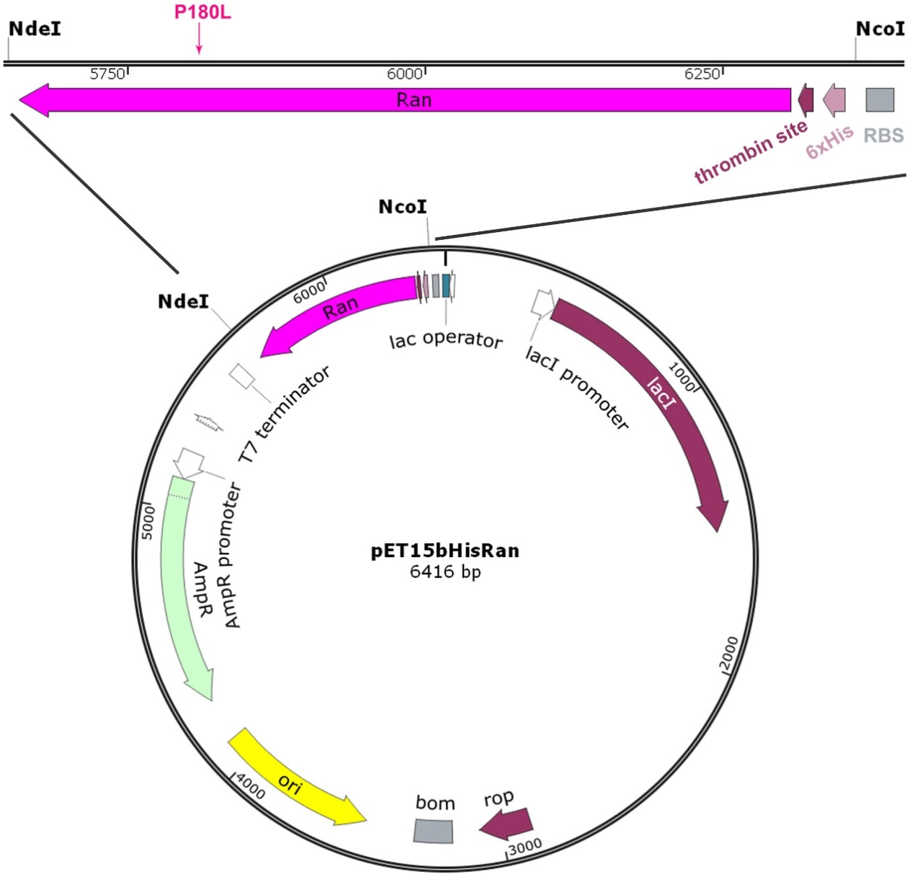
Figure S2. The vector map including inserted Ran^{WT} or Ran^{P180L}. Inserted Ran^{WT} or Ran^{P180L} (denoted in pink) was colored in magenta. RBS (ribosome binding site) was colored in gray at the top. AmpR (Ampicilin resistance) was colored light green. Ori (origin of replication) was colored yellow. Bom: basis of mobility region. Rop: rop protein. lacI: lac repressor.
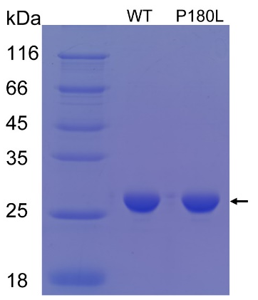
Figure S3. SDS-PAGE of pure 6x his-Ran. The pure proteins were indicated with black arrow.

